
Cloud – Outcome 4
By Aaron Cairns


Contents
Google Gemini 2
How to use this service 3
Meta AI 6
How to use this service 7
References 10

Google Gemini

For my first AI service I used Google Gemini. Gemini is a cloud-based AI service developed by Google. Because Gemini works through cloud computing, all the processing and AI generation takes place on Google’s remote servers instead of on the user’s own computer. This means users only need an internet connection and a web browser to access the AI.
I decided to use Gemini to generate a revision quiz for Networking. Gemini is useful for educational tasks because it can quickly generate questions, answers and explanations.
The first thing I did was navigate to the Gemini website located at Google Gemini.
The next step was to create a prompt telling the AI exactly what I wanted it to do.
For this task I entered the following prompt:
“Create a 15 question multiple choice quiz on Network Infrastructure covering IP addresses, routers, switches, wireless security, topology types and the OSI model.”
I entered the prompt into the text box and pressed Enter.
After submitting the prompt, Gemini began generating the quiz automatically. The AI created a full set of multiple-choice questions along with possible answers.
Once Gemini finished generating the quiz, I reviewed the questions to make sure they were correct and useful for revision purposes.
Gemini also allowed me to continue the conversation by asking follow-up questions and requesting explanations for any incorrect answers.
This image shows the completed quiz generated by Gemini and demonstrates that the AI successfully completed the task requested in the prompt.
Advantages of Gemini
- Easy to use interface
- Fast response times
- Useful for learning and revision
- Accessible on phones, tablets and computers
- No powerful hardware required
Disadvantages of Gemini
- Requires internet access
- Some information may occasionally be inaccurate
- Certain advanced features require payment
- Privacy concerns when entering personal information

How to use this service

- Access Google Gemini - Gemini
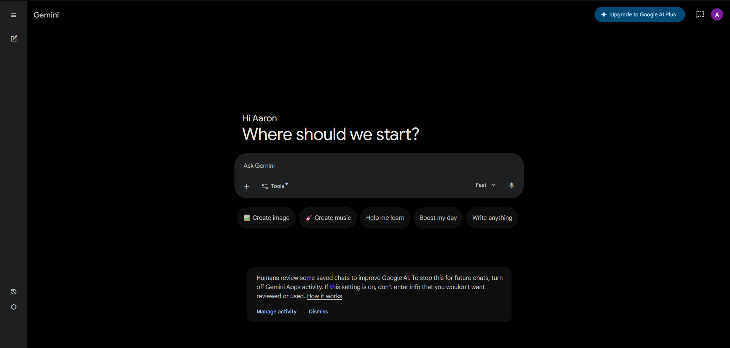

- Once you are on the website Sign in with your google account
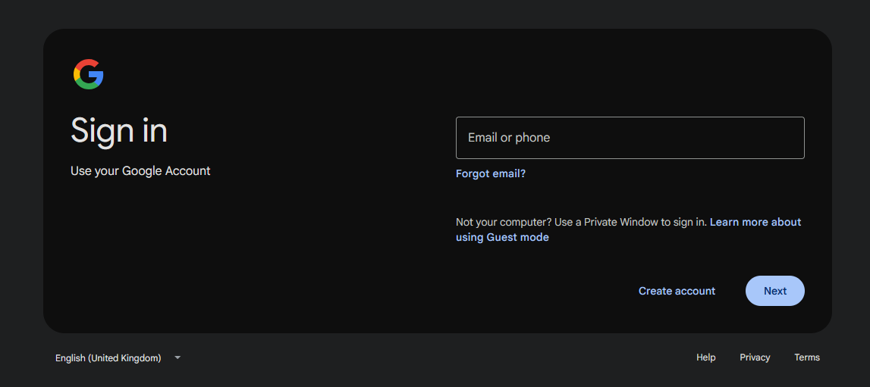

- Once you have signed in you should now have full access to Gemini, from here just insert a prompt for the AI.

Example prompt: “Who invented the first telephone?”
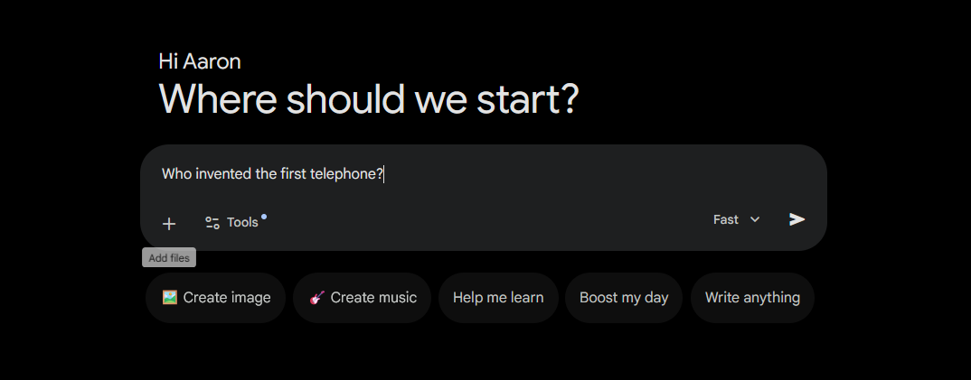

- Read the answer the chatbot has given you to your question and if you want to ask it more you can continue the conversation by adding more follow up questions.
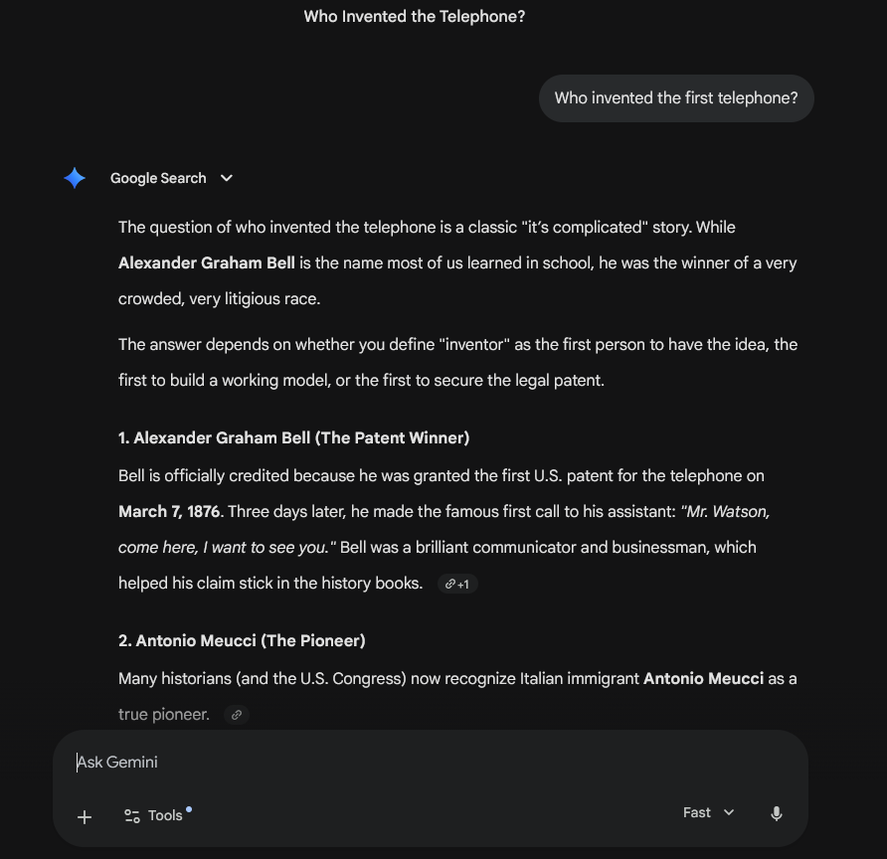
- Gemini also offers extra features which include generate ideas, translate languages, summarise text and many more.
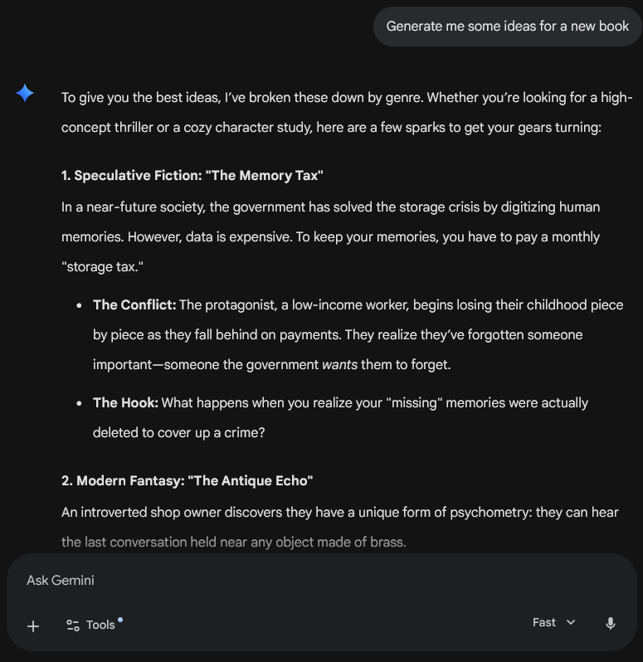

- Some of the features are restricted to a paid subscription fee
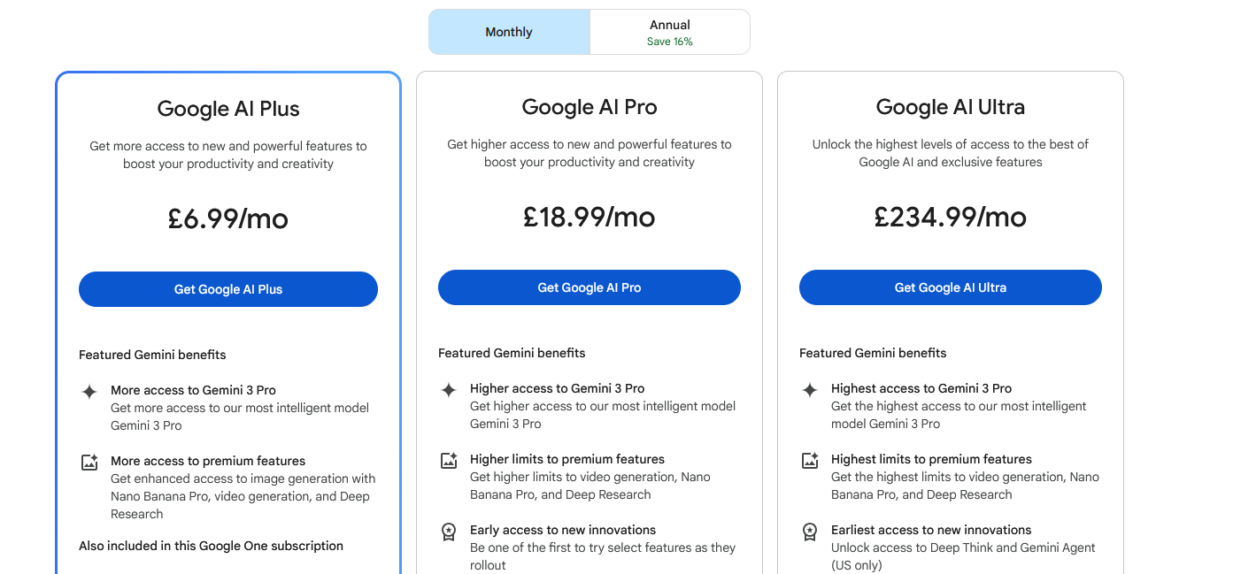

Meta AI

Meta AI is also a cloud-based AI service because all AI processing happens on Meta’s remote cloud servers. When users send prompts through Meta AI, the request travels through the internet to Meta’s servers, where the AI model processes the information and generates a response.
This cloud-based approach allows Meta AI to operate inside platforms such as Facebook, Instagram, WhatsApp and Messenger without requiring users to install large AI programs on their devices. The service can therefore be accessed quickly from smartphones, tablets, and computers.
Cloud computing also allows Meta AI to handle millions of users simultaneously. Since the infrastructure is managed centrally by Meta, updates and improvements can be introduced automatically without requiring users to manually update the software.
Advantages;
- Integrated into popular social media apps
- Easy to access on mobile devices
- Fast AI-generated responses
- Supports image generation and conversation
- Useful for communication and creativity
Disadvantages;
- Requires internet access
- Some features may not be available in all countries
- AI responses may occasionally contain errors
- Privacy concerns related to social media integration

How to use this service

- Access the Meta AI website – Meta AI
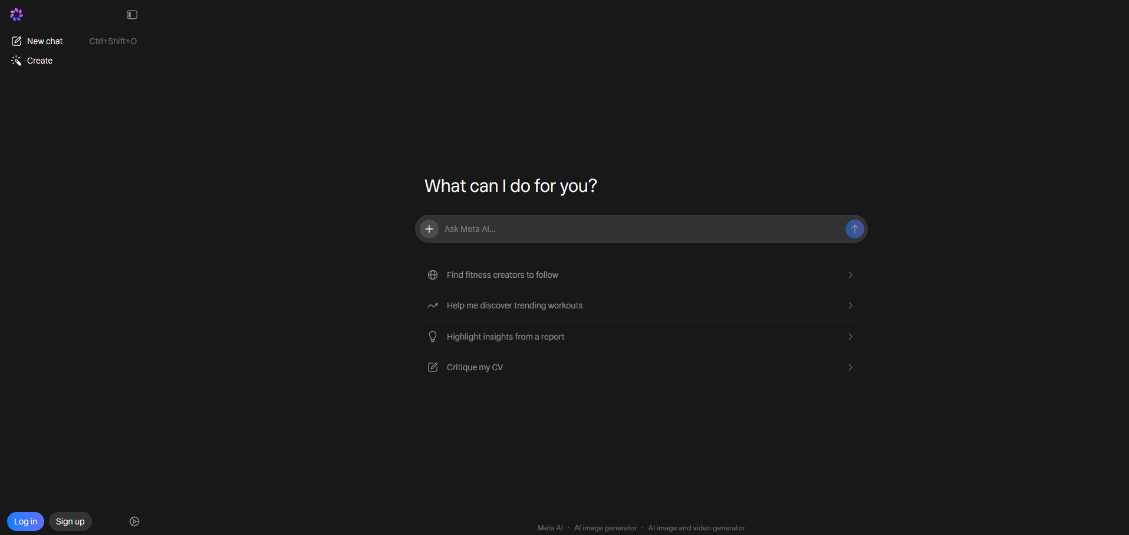

- Sign in or create an account to get full access to all free features


- Enter a prompt

Example prompt: “Tell me the benefits of running everyday”
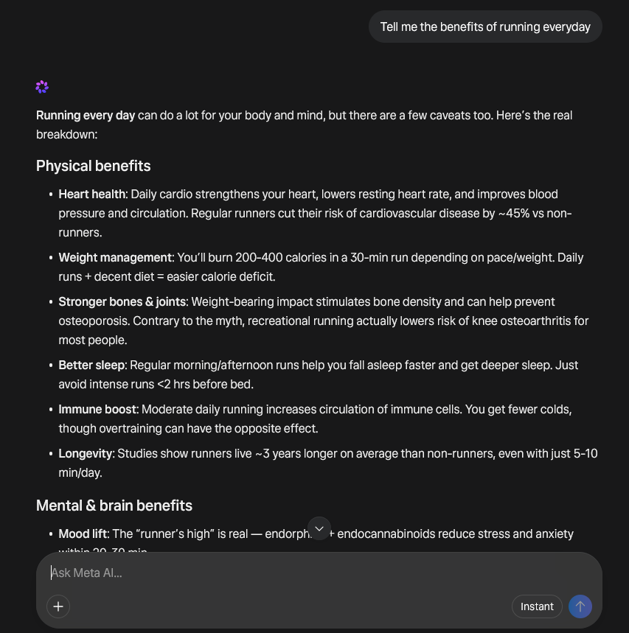

- The AI will write out its response to your question which you can ask it more to continue the conversation if needed


- Meta AI can also provide additional free features like generate an image from a prompt

Example prompt: “Generate me an image of 2 swans”
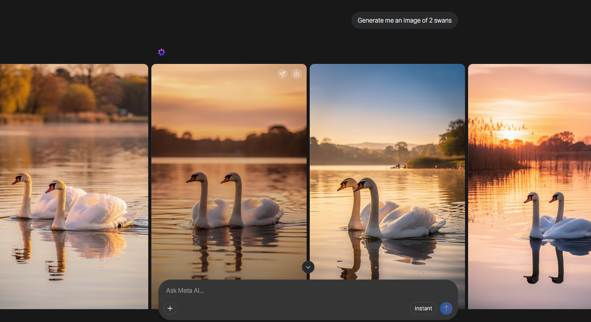

In conclusion, Google Gemini and Meta AI are both powerful examples of cloud-based artificial intelligence services. Both platforms use remote cloud servers to process user prompts and generate intelligent responses quickly. Google Gemini focuses strongly on productivity, learning, and research assistance, while Meta AI is designed to enhance communication and social media experiences.
These AI services demonstrate how cloud computing allows users to access advanced AI technology without needing expensive computer hardware. As AI continues to develop, cloud-based services such as Gemini and Meta AI are likely to become even more important in education, business, and everyday life.

References

(Google DeepMind, n.d.) - https://deepmind.google/models/gemini/

(Meta AI, n.d.) - https://ai.meta.com/meta-ai/

